

**Malaysia Architectural Journal**

**Topic: An exploratory review on the development of traditional Malay settlement in East Coast Malaysia**

Sharyzee Mohmad Shukri1* Idris Taib2

*1,2 Faculty of Architecture and Built Environment, Infrastructure University Kuala Lumpur,*

*Malaysia*

*\** [sharyzee@iukl.edu.my](mailto:sharyzee@iukl.edu.my)

*Received: 1st May 2020 Final version received: 23rd July 2020*

This paper intends to perform a close reading and skeptical reflection on Henri Lefebvre’s ideas of ‘urban form’ by referencing to the book – *The Urban Revolution* (1970; English translation published in 2003). Lefebvre’s major urbanism debate – The Urban Revolution was published in the 1970. Despite nearly half a century this book was published, it continues to serve as a foundational literature for coming generations of urban thinkers or scholars. This paper is not a book review of Lefebvre’s *The Urban Revolution*, but the intention of this paper is to appraise closely on the selected theme of ‘urban from’ as discussed in this book. The proposition in performing this close reading is principally to ask: how have the architectural designs and planning regimes of urbanism become an urban practice of ideology, utopia and power? The paper suggests a new framework of interpretation which could be useful for architects and architectural students to comprehend or reflect on this highly dialectic concept of urban form.

**Keywords**: Henri Lefebvre, Urban Form, Utopia, Architectural Criticism, Close Reading

1. **INTRODUCTION**

We request authors to follow this guideline and format their manuscripts exactly the same as this document. The easiest way to do this is download this template and replace its contents with those in your manuscript.

Traditional settlement defined as traditional neighborhood community in which both of physical characteristics and its occupants, persist with their living traditions, skills, and other cultural practices. – Explain and divide your introduction according to the following aspects:

* Define traditional settlement.
* Brief the problem (general and specific) with regard to traditional settlement accordingly.
* Explain the aim of the study.
* Write down your objectives- NOT your AIM and Objectives of your thesis. ONLY for the paper. Just a small study. In this case- A review on development and status of the 37 traditional that used to exist in Terengganu.

1. **LITERATURE**

All material on all pages should fit within an area of A4 (21 x 29.7 cm), 2.8 cm from the top of the page and ending with 2.4 cm from the bottom. The left and right margins should both be 2.4 cm.

This paper intends to give an overview of the studies that have been done on understanding the development process of the traditional Malay settlement.

* Define Malay settlement
* Define it characteristics.
* Explain the importance.
* Give examples of good preserved traditional settlement around the world.

1. **METHODOLOGY**

The method of this research is focusing on the development and characteristics of 37 numbers of traditional Malay settlements by an in-depth literature review located in Kuala Terengganu, Dungun, Kemaman and Besut region.

* Explain the method-Qualitative.Content analysis/literature review + site visit
* Explain why you chose qualitative? Why literature review and site visit? Why you need site visit? Is it because previous research used similar method? If YES. GOOD. Means that your method is correct and your results are valid. You are not creating or cheating in research. List down past researches with similar studies as your paper?
* Explain the type of literature that you review. How many? Which years? How do you analyse the info gathered?
* Explain on your site visit. How many district involved? How many settlements discovered? Which years? How do you analyse the info gathered?

1. **FINDING: XXXXXXXXXXXXXXX**

This paper discusses the traditional Malay settlement in East Coast Malaysia formed influenced by the activities of the people along the coastal plain and the river banks. It was identified that the seafaring society from ancient countries engaged in trading, agriculture, and spreading religion and thus they build their settlements.

* Divide and categorise the settlements according to districts
* Explain the characteristics and special attributes that makes it special and worth as heritage
* Explain what happened to the settlements according to its existing condition ie.- very good? Good?Bad?Gone?

1. **DISCUSSION: XXXXXXXXXXXXX**

Here is the section where you should give reason, debate and discuss on the results that you have presented.

* If good, what makes it good until today? Has it been preserved?
* If bad, why? What happened? What are the problems? How do we go about?
* If gone. Why it is gone? Is it because of natural disaster or demolished by development/man factors?
* It is in the discussion where you relate back your findings with your literature review on what have other part of the world do to safeguard or protect to enhance their traditional settlement? Which settlement in your study potential to carry out those practices?

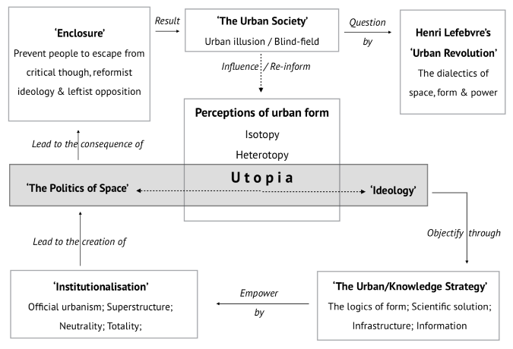

Figure 1: Examples of the figures

1. **CONCLUSION: XXXXXXXXXXXX**

The findings from this exploratory review conclude that the characteristics of the traditional Malay settlement have the potential to be conserved and preserved for sustainable development of the present and future through promoting the physical landscape setting and social sustainability of the past.

* Conclude the article by answering-How can this help rural planning and landscape development? Or built environment?

1. **REFERENCES**

Allen, M. 2017. *The sage encyclopedia of communication research methods* (Vols. 1-4). Thousand Oaks, CA: SAGE Publications.

Brummett, B. 2019. *Techniques of close reading* (Second ed.). Los Angeles: SAGE.

Howard, E., Sir. 1902. *Garden cities of to-morrow: Being the second edition of "tomorrow : A peaceful path to real reform"*. London: S. Sonnenschein & Co.

Le Corbusier, 1933 & 1964. *The Radiant City: Elements of a Doctrine of Urbanism to be Used as the Basis of Our Machine-Age Civilization*. Orion P.

Lentricchia, F., & DuBois, A. 2003. *Close reading: The reader*. Durham [N.C.]: Duke University Press.

Lefebvre, H., & Project Muse. 1970; 2003. *The urban revolution*. Minneapolis: University of Minnesota Press.

Park, R. E., Burgess, E. W., & Sampson, R. J. 1925; 2019. *The city*. Chicago: University of Chicago Press.

Stanek, Ł., Schmid, C., & Moravánszky, Á. 2014. *Urban revolution now: Henri Lefebvre in social research and architecture*. Burlington: Ashgate Pub.

Wright, Frank Lloyd, 1932. *The disappearing city*. New York :W.F. Payson.